Exists in Array test case results

This program checks if a value exists in an array. If it does the program outputs that it does exist. If it doesn’t the value is appended to the end of the array.

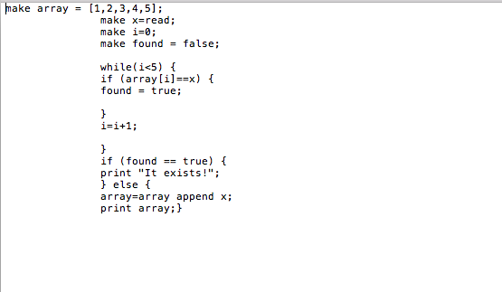

Result if value exists in array

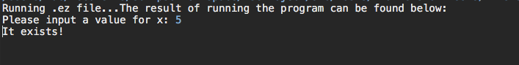

Result if value does not exist in array

